Answers homework question 4 – september 2021

1 | Database(s): Ovid MEDLINE(R) ALL 1946 to September 23, 2021  # Searches Results  1 exp Vitamins/ 334779  2 exp Vitamin A/ 45453  3 Niacin/ 10881  4 exp Ascorbic Acid/ 43558  5 exp Vitamin D/ 63034  6 (vitamin* or niacin or ascorbic or ascorbate).ti,ab. 267536  7 or/1-6 [Vitamins] 466653  8 exp Hormones/ 1422667  9 exp Endocrine Glands/ 430550  10 (hormon* or endocrin*).ti,ab. 681586  11 or/8-10 [Hormones] 1939973  12 7 and 11 [Vitamins + Hormones] 54240  13 Dermatology/ 19554  14 dermatolog*.ti,ab. 62495  15 or/13-14 [Dermatology] 70115  16 12 and 15 [Vitamins + Hormones + Dermatology] 247
2 | Ovid Medline & Epub  1. Dermatology/ or Skin/ or Skin Diseases/  2. exp Avitaminosis/ or exp Hormone Antagonists/ or exp Hormones/ or exp Vitamins/  3. ((derm* or skin) and (avitaminos* or hormon* or vitamin*)).ti,kf. or ((derm* or skin) adj3 (avitaminos* or hormon* or vitamin*)).ab.  4. (1 and 2) or 3  Additions/Edits I would test:  - Keep Skin Diseases (MeSH) not exploded and add MeSH for desired narrower diseases, example: Atopic Dermatitis (MeSH)  - Focus on hormone or vitamin therapies:  - Use Skin/drug effects, therapy MeSH subheadings  - Use Skin Diseases/drug therapy, prevention and control, therapy MeSH subheadings  - Keep hormone and vitamin general MeSH not exploded and add MeSH for desired narrower terms, example: Vitamin B 12 (MeSH)  - If specific hormone or vitamin MeSH terms used, then include specific hormone or vitamin deficiency term, if available  - If still need to narrow strategy retrieval, add “therapeutic use” subheading to hormone and vitamin MeSH terms  First attempt (way too broad)  1. Dermatology/ or exp Skin/ or exp Skin Diseases/ or (derm* or epiderm* or skin).mp.  2. exp Avitaminosis/ or exp Vitamins/ or (avitaminos* or vitamin*).mp.  3. exp Hormone Antagonists/ or exp Hormones/ or hormon*.mp.  4. 1 and (2 or 3)  Second attempt (better, but too broad)  1. Dermatology/ or Skin/ or Skin Diseases/ or (derm* or skin).tw,kf.  2. exp Avitaminosis/ or exp Vitamins/ or (avitaminos* or vitamin*).tw,kf.  3. exp Hormone Antagonists/ or exp Hormones/ or hormon*.tw,kf.  4. 1 and (2 or 3)
3 | S1 exp vitamins OR vitamin$.ti,ab OR exp vitamin a OR exp “vitamin b 12” OR exp vitamin d OR vitamin$.ti,ab (I’d add thesaurus terms for the other types of vitamin B)  S2 hormones.sh OR hormon$.ti,ab  S3 (dermatology OR skin diseases OR dermatologic agents).sh or exp acneiform eruptions/ or exp dermatitis/ or exp erythema/ or exp exanthema/ or exp facial dermatoses/ or exp hand dermatoses/ or exp keratosis/ or exp leg dermatoses/ or exp lipomatosis/ or exp lupus erythematosus, cutaneous/ or exp mastocytosis/ or exp morgellons disease/ or exp necrobiotic disorders/ or exp necrolytic migratory erythema/ or exp nephrogenic fibrosing dermopathy/ or exp photosensitivity disorders/ or exp pigmentation disorders/ or exp prurigo/ or exp pruritus/ or exp pyoderma/ or exp rosacea/ or exp scalp dermatoses/ or exp sebaceous gland diseases/ or exp skin abnormalities/ or exp skin diseases, eczematous/ or exp skin diseases, genetic/ or exp skin diseases, infectious/ or exp skin diseases, metabolic/ or exp skin diseases, papulosquamous/ or exp skin diseases, vascular/ or exp skin diseases, vesiculobullous/ or exp skin neoplasms/ or skin ulcer/ or exp sweat gland diseases/ or exp xanthogranuloma, juvenile/ OR (dermatology$ OR skin disease$ OR acne$ OR derm$ OR erythema).ti,ab  (I’d add additional free text terms that represent all the thesaurus terms for skin diseases.)  S5 1 AND 2 AND 3  Is this a scenario where using supplementary concepts would be useful? I’m only passingly familiar with them so I’m not sure.
4 | (vitamins OR hormones) AND dermatology AND (treatment outcome OR therapy OR safety OR effectiveness OR efficacy)
5 | Vitamins AND hormone AND clinical dermatology  Vitamin AND hormone AND dermatology  ('vitamin'/exp/mj OR 'hormone'/exp/mj) AND 'dermatology'/exp/mj
6 | Yes this is exactly what I spend too much time on!  Exp Hormones/ OR Exp Vitamins/ OR Exp Dietary Supplements/ OR any of the Mesh terms that can be exploded from Vitamins [Drug Terms] OR any of the Mesh terms that can be exploded from Hormones [Drug Terms] OR exp Hormone Replacement Therapy/  (Vitamin* OR Provitamin* OR all of the hormone mesh terms, supplementary concepts and entry terms OR all of the vitamin mesh terms, supplementary concepts and entry terms OR Dietary supplement* OR Prebiotic* OR Synbiotic* OR yeast adj2 dried OR herbal supplement* OR neutraceutical* OR neutriceutical* OR food supplement*).mp. OR (dietary adj2 supplement*).mp. OR (yeast adj2 dried).mp.  AND  Exp Skin Diseases/ OR Exp Skin Manifestations/ OR Exp Skin/  (Skin Disease* OR all more specific mesh terms and entry terms as keywords).mp. OR (Skin adj2 Manifest*).mp. OR (all more specific mesh terms and entry terms as keywords).mp. OR (all more specific mesh terms and entry terms as keywords) OR derma*.mp.  Is it worth adding concepts of therapy/drug therapy/therapeutic use into the strategy? Would have to talk to the research team and test.
7 | Vitamin* and (hormones, hormone substitute or hormone receptor agonists/therapeutic use) and (dermatology or skin disease*/drug therapy)
8 | (Vitamins OR Avitaminosis OR Vitamin deficiency OR Retinoids) AND (Hormones OR Dermatologic agents) AND (“Clinical dermatology” OR Skin OR Dermatology OR Skin manifestations)
9 | ((exp Avitaminosis/ OR exp Vitamins/ OR exp Vitamin K/ OR Exp Vitamin B 12/ OR exp Vitamin E/ OR exp Vitamin D/ OR exp Riboflavin/) or (Vitamin* OR Provitamin* OR Cobalamin* OR Eritron OR Tocopherol* OR Cholecalciferol OR Ergocalciferols OR riboflavin)) AND ((exp Hormones/ or exp Hormone Antagonists/) or (melatonin or hydroxycorticosteroid* OR glucocorticoid* OR 17-ketosteroid*)) AND ((Dermatology/ OR exp Skin Diseases/ OR exp Skin Manifestations/ OR exp Dermatologic Surgical Procedures/ OR exp Dermatologic Agents/) or (Dermatolog* OR Dermatos* OR Cellulite OR Dermabrasion OR Antipuritic*))
10 | (a) Step A: extract they key terms:  vitamins  hormones  dermatology  (b) Step B: search terms in Pubmed Mesh  vitamins :  micronutrients  hormones:  Anabolic Agents  Androgens  Cannabinoid Receptor Modulators  Cannabinoid Receptor Agonists  Cannabinoid Receptor Antagonists  Estrogens  Estrogens, Non-Steroidal +  Glucocorticoids  Incretins  Mineralocorticoids  Progestins  dermatology:  Skin Diseases  Step C: I searched the original terms and got 0 results.  ((vitamins) OR hormones) AND dermatology
11 | 1 Skin/ or Skin Diseases/  2 Skin Neoplasms/  3 Wound Healing/  4 Skin Care/ or Skin Aging/  5 Dermatologic Agents/  6 Skin Manifestations/  7 Dermatology/  8 (skin diseases or synonyms or dermatolog*).ti,ab.  9 or/1-8  10 Hormones/ OR synonyms  11 Vitamins/  12 Vitamin E/  13 Vitamin D/ OR synonyms  14 (hormone* or vitamin* OR synonyms).ti,ab.  15 or/10-14  16 9 and 15  17 Animals/  18 16 not 17  19 18  20 limit 19 to (english language and yr="2011 -Current")
12 | "Dermatology"[Mesh] OR "clinical dermatol*"[tiab]  "Hormones"[MESH] OR "hormone*" OR "Vitamins"[Mesh] OR vitamin[tiab]  (This gives me 973 results. Usually our researchers ask more specific questions so I'm stumped as to how I would narrow this down at the moment.)
13 | Vitamin OR vitamins (more terms) AND hormone OR hormones (more terms) AND dermatology (more terms) OR “clinical dermatology”
14 | ("Dermatologists"[Mesh] OR "Dermatology"[Mesh] OR "Skin Manifestations"[Mesh] OR "Skin Diseases"[Mesh] OR "Skin"[Mesh] OR (add appropriate keyword synonyms here))  AND  ("Vitamins"[Mesh] OR "Vitamins" [Pharmacological Action] OR "Provitamins"[Mesh] OR "Vitamin B Complex"[Mesh] OR (add appropriate keyword synonyms here))  AND  ("Hormones"[Mesh] OR "Hormones" [Pharmacological Action] OR "Adrenal Cortex Hormones"[Mesh] OR "Gastrointestinal Hormones"[Mesh] OR "Gonadal Hormones"[Mesh] OR "Hormones, Ectopic"[Mesh] OR "Peptide Hormones"[Mesh] OR "Thymus Hormones"[Mesh] OR "Thyroid Hormones"[Mesh] OR "Hormone Replacement Therapy"[Mesh] OR "Melatonin"[Mesh] OR (add appropriate keyword synonyms here))
15 | 1 "hormones, hormone substitutes, and hormone antagonists"/ or dermatology/  2 organic chemicals/ or "hormones, hormone substitutes, and hormone antagonists"/ or provitamins/ or hormones/ or vitamins/  3 1 or 2  4 limit 3 to humans
16 | At it's most basic my search would be:  exp vitamins/ or vitamin*.ti,ab,kf.  AND  exp hormones/ or hormone*.ti,ab,kf.  AND  exp skin/ or exp dermatology/ or (skin or dermis or corium or epidermis or dermatol*).ti,ab,kf.  But I really want to know if the patron wants all vitamins, vitamins and minerals, other micronutrients, etc and then I would add those into the "vitamins" concept with their corresponding MeSH terms and keywords. Hormones as well: which ones? All human hormones? And add those into the "hormones" concept with MeSH terms and keywords. For the dermatology concept, I'd want to know more specifics: what outcomes are they looking for? The effect of vitamins and hormones on a specific disease or process like skin aging? Recovery from a disease? Susceptibility to a disease? Are they looking at vitamin/hormone supplementation? Topical treatments? I would want to dig into the MeSH terms and keywords to be as specific as possible for these concepts.
17 | 1. dermatology/ OR exp dermatologic agents/ OR exp skin care/ OR exp skin diseases/  2. (Dermatolog* OR skin disease* OR skin care).ti,ab.  3. exp patients/ OR patient care/  4. (patient* OR patient care OR clinical).ti,ab.  5. exp hormones/ OR exp hormone replacement therapy/ OR exp "hormones, hormone substitutes, and hormone antagonists"/  6. (hormone*).ti,ab.  7. exp vitamins/  8. (vitamin*).ti,ab.  9. #1 OR #2  10. #3 OR #4  11. #5 OR #6  12. #7 OR #8  13. #9 AND #10 AND #11  14. #9 AND #10 AND #12  15. Limit for date; humans; English language; etc.
18 | 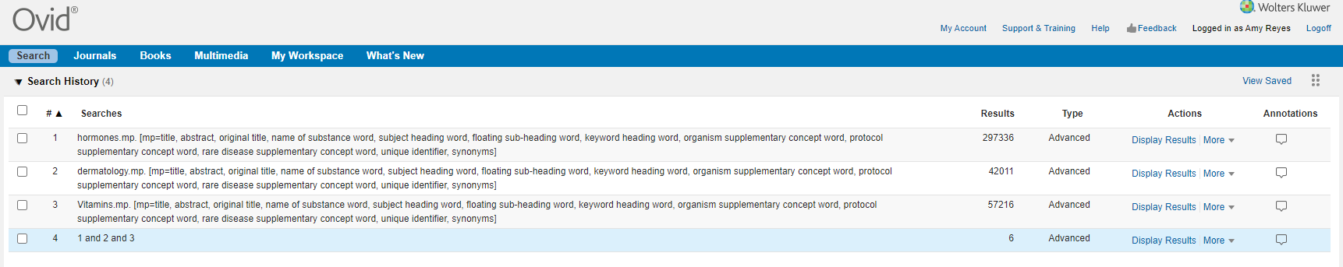  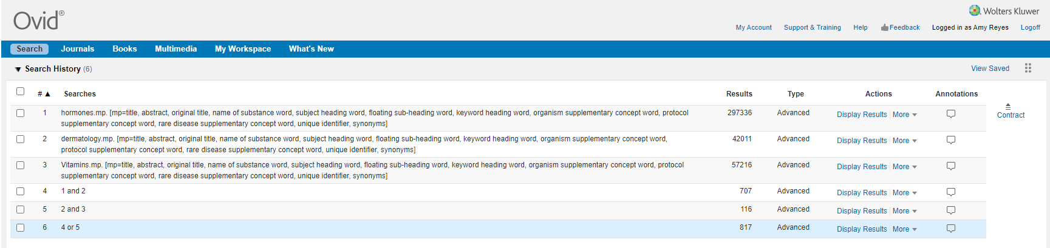
19 | Exp Vitamins [Mesh] OR Exp Hormones OR Exp Hormone Replacement Therapy OR (specific vitamins or hormones listed in titles and abstracts)  AND  Exp Skin Disease [Mesh] OR (dermatol*.ti.) OR (skin.ti.) OR (list specific names of dermatologic conditions in title or abstract like rosacea, melanoma, alopecia, etc.)  Narrow with RCT limits:  ((randomized controlled trial.pt. or controlled clinical trial.pt. or randomized.ab. or placebo.ab. or drug therapy.fs. or randomly.ab. or trial.ab. or groups.ab.) not (exp animals/ not humans.sh.))  Combine with (OR) second search results limited to systematic reviews and meta-analyses
20 | (Hormones, Hormone Substitutes, and Hormone Antagonists [MeSH] OR hormone*[tiab] OR Vitamins [MeSH] OR vitamin* [tiab]) AND (Dermatology [Majr] OR dermatolog*[tiab] OR (Skin Diseases/therapy[Majr] OR Skin Diseases/drug therapy [Majr])) AND Humans [MeSH]  Given more time, I would OR in more text words for the concepts hormones, vitamins, and the treatment of skin problems, and also OR in narrower terms for different skin maladies, vitamins, and hormones.
21
22
23
24
25

